Dept of Higher Education, U.P.

CAREER ADVANCEMENT SCHEME (CAS)

PROMOTIONS FOR ASSISTANT PROFESSOR, ASSOCIATE PROFESSOR IN COLLEGES.

(As per revised guideline of UGC notified in Gazette of India, Part III, Section-4, No-271 dated 18 July 2018 and U.P. Govt. Order No. 600/Satter-1-2019-16(114)/2010 dated 28-06-2019)
Application for Assistant Professor Stage-II (Academic Level 10 to 11) /
Assistant Professor Stage-III (Academic Level 11 to 12)/
Associate Professor Stage-IV (Academic Level 12 to 13A)

PART-I: PERSONAL DATA
(To be filled up by the Assistant Professor/Associate Professor)

 | Application for the promotion of (please √) |  |  Assistant Professor Stage-II (AL-10 to 11)   Assistant Professor Stage-III (AL-11 to 12)   Associate Professor Stage-IV (AL-12 to 13A)
01 | Name (In BLOCK Letters)
02 | Father’s/Mother’s/Husband Name
03 | Department
04 | Mobile number
05 | Email ID
06 | College Name & Address
07 | Website
08 | College NAAC Grade and date of validity
09 | Current Designation and Academic Level  and pay
10 | Date of first Joining as regular  (in Govt. College of U.P.)
11 | Which position and Academic Level  (11, 12, 13A) are  you an applicant under CAS
12 | Date of eligibility for promotion
13 | Order number and date of last promotion (if  applicable)
14 | Assessment period
15 | Date of required RC/OC/ short term course as  per UGC regulation 2018, Part-II of this form
16 | Date of award of Ph.D.  (Date is Considered as displayed on degree or  Approved by EC of University, Proof to be attached)  Ph.D. is an essential qualification for promotion  in Academic Level 13A (Page 81 of UGC  regulation 2018)
17 | Date and Place of Birth
18 | Sex
19 | Nationality
20 | Indicate whether belongs to SC/ST/OBC category
21 | Address Postal
22 | Address Permanent
23 | Academic Qualifications:- (High School till Post Graduation)
244 | Examination Name of Board/University Year of Passing Division /Class Grade Subject/s Rank and Remark if any  Matriculation /High School  Intermediate  (10+2)  B.A. /B.Sc. / B.Com. /& equivalent  M.A./ M.Sc./ M.Com. & Equivalent  Other , if any

25 Research Degree (s):

 | Degree | Title | Date of Award | University
 | M. Phil
 | Ph.D. / D. Phil
 | D.Sc. / D. Lit
Other (Please
Specify)
26 Particulars of NET/JRF/SLET/GATE etc.

 | Name of the  Test | Name of the Test conducting body | Month  and Year | Roll No. | Subject | Score, where applicable
27 Service Record:

 | Sr.  No | Post/  Designation | Name of Employer | Date of |  | Pay Scale/Pay Band & AGP | Reason of Leaving | Major achievement
 |  |  |  | Joining | Leaving
 | 1. | Assist. Prof. | Principal, Meerut college, Meerut | 02.02.2009 | Contd. | Rs.15600-39100, AGP Rs.- 7000/- (present AGP) | - | -
28 | Period of teaching experience
 | a) P.G. Classes (in years)
 | b) U.G. Classes (in years)
29 | Research Experience excluding years spent in M.Phil.  / Ph.D. (in years)
30 | Fields of Specialization under the Subject / Discipline  (if any)

PART-II

CAREER ADVANCEMENT SCHEME (CAS)

PROMOTIONS FOR ASSISTANT PROFESSOR, ASSOCIATE PROFESSOR IN COLLEGES.)

Assessment Period………………………Stage…………………..

31-Eligibility and Criteria for CAS Promotion: (as specified in Clause 6.4(B) of UGC Regulation 2018)
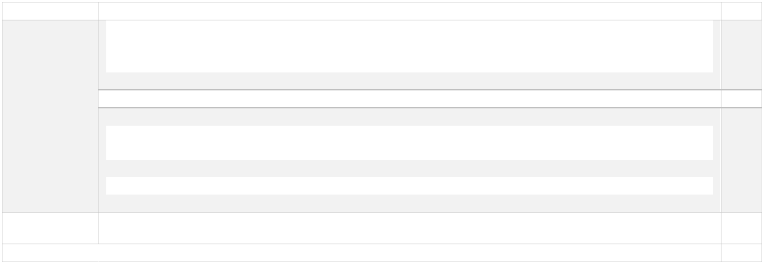
Stage-I | Assistant Professor (Academic Level 10) to Assistant Professor (Senior Scale/Academic Level 11)
Eligibility | Assistant Professors who have completed four years of service and having a Ph.D. degree or five years of
 | service and having an M.Phil. / PG Degree in Professional Courses, such as LLM, M.Tech.,M.V.Sc.,
 | M.D., or six years of service for those without Ph.D./M.Phil./ PG Degree in Professional courses
 | Attended one OC of 21 days on teaching methodology
 | Completed one RC / Research Methodology Course
 | or | Any two of the following: Workshop, Syllabus Up-gradation Workshop, Training Teaching-
 | Learning- Evaluation, Technology Programmes and Faculty Development Programmes of at least one week (5 days) duration
Or Completed one MOOCs course (with e-certification or development of e-contents in four quadrants
/M OOCs course during the assessment period.

Proof page no

CAS Promotion Criteria

Stage-II

He/she gets ‘satisfactory‘ or ‘good‘ grade in the annual performance assessment reports of at least 3/4/5 of the last 4/5/6 years of the assessment period as the case may be, as specified in Appendix II, Table 1,
The promotion is recommended by a screening-cum-evaluation committee.
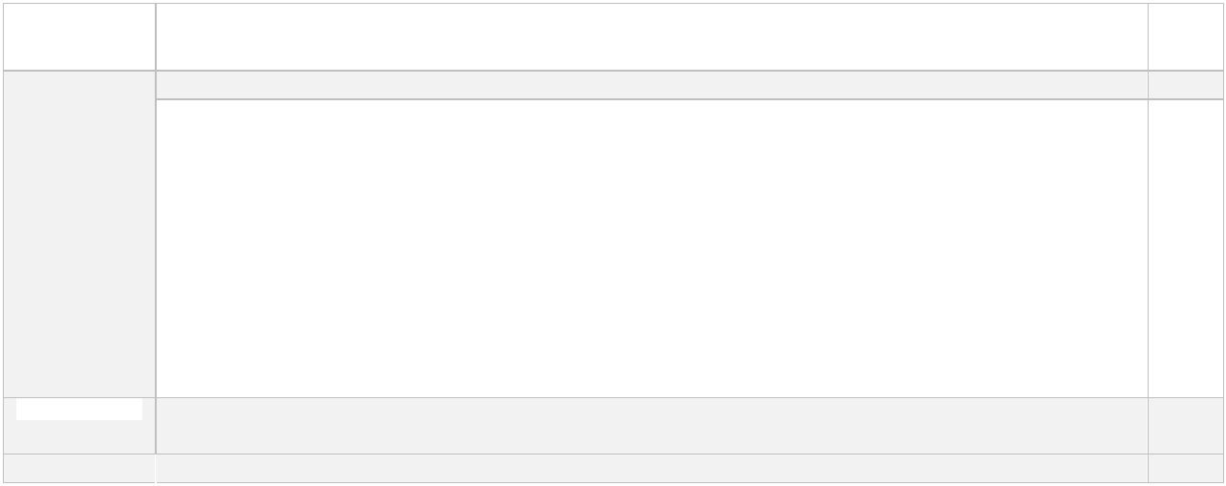

Assistant Professor (Senior Scale/Academic Level 11) to Assistant Professor (Selection Grade/Academic Level12)

Part-

III

Proof

page no

Eligibility Assistant Professors who have completed five years of service in Academic Level 11/Senior Scale

CAS Promotion Criteria

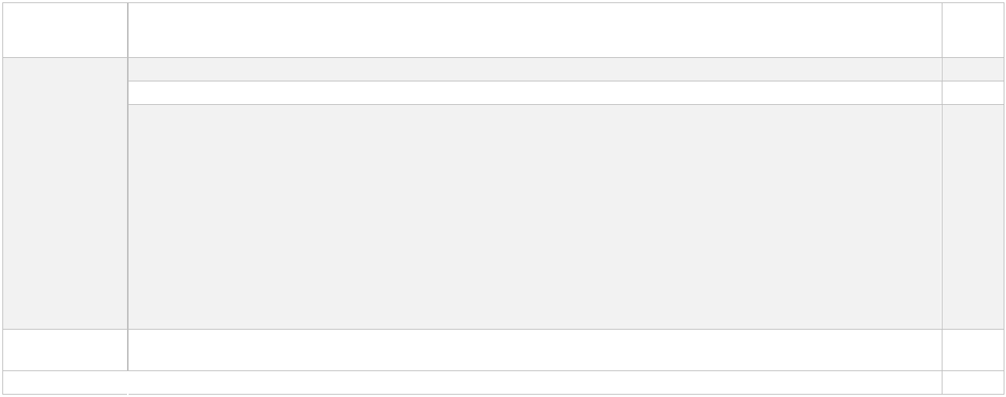
Stage-III

Eligibility

CAS Promotion Criteria

Any two of the following in the last five years of Academic Level-11/ Senior Scale:

Completed courses/programmes from among the categories of Refresher Courses/Research Methodology course/Workshops/Syllabus Up Gradation Workshop/ Teaching-Learning-Evaluation/ Technology Programmes/ Faculty Development Programme/ Syllabus Up-gradation Workshop/ Teaching-Learning-Evaluation/ Technology Programmes/ Faculty Development Programmes of at least two weeks (ten days) duration

or completed two courses of at least one week (five days) duration in lieu of every single course/programme of at least two weeks (ten days) duration);

or completed MOOCs course in the relevant subject (with e-certification); or ontribution towards development of e-content in 4-quadrant (at least one quadrant) minimum of 10 modules of a course/contribution towards development of at least 10 modules of MOOCs course/ contribution towards conducting of a MOOCs course during the period of assessment.

The teacher gets ‘satisfactory‘ or ‘good‘ grade in the annual performance assessment reports of at least 4 of the last 5 years as prescribed in Appendix II, Table 1
The promotion is recommended by a screening-cum-evaluation committee.

Assistant Professor (Selection Grade/Academic Level 12) to Associate Professor (Academic Level 13A)

completed Three years of service in (Selection Grade/Academic Level 12)

A Ph.D. degree in subject relevant /allied/relevant discipline

Any one of the following

RC/ Methodology Workshop/Syllabus Up-gradation Workshop/ Teaching- Learning-Evaluation Technology Programme/ Faculty Development Programme of at least two weeks (ten days) duration Or

two courses of at least one week (five days) duration in lieu of every single course/programme of at least two weeks (ten days) duration);
or

completed one MOOCs course (with ecertification); or contribution towards development of e-contents in 4-quadrant(at least one quadrant) minimum of 10 modules of a course/contribution towards development of at least 10 modules of MOOCs course/ contribution towards conduct of a MOOCs course during the period of assessment.

The teacher gets ‘satisfactory‘ or ‘good‘ grade in the annual performance assessment reports of at least 2 of the last 3 years as prescribed in Appendix II, Table 1
The promotion is recommended by the selection committee in accordance with these Regulations.

Part-

III

Proof

page no

Part-

III

PART-III

CAREER ADVANCEMENT SCHEME (CAS)

PROMOTIONS FOR ASSISTANT PROFESSOR, ASSOCIATE PROFESSOR IN COLLEGES.)

Assessment Period………………………Stage…………………..

- Assessment Criteria and Grading of Activity for College Teachers
(as specified in Clause 6.1 and Appendix II, Table 1 of UGC Regulation 2018)
(Please see detailed instructions in UGC- Gazette of India, Part III, Section-4, No-271 dated 18-7-2018)
Serial number | Nature of activity | Grading Criteria | Assessment Period  ………… to …………  Write “Good”, “Satisfactory”, or “Not  Satisfactory” (as the case may be) in  academic year column of concerned  category, applicable for you. Assessment must based on evidence produced by the teacher |  |  |  |  |  |  | Activity Grading approved by IQAC |  |  | Annexure No | Page No | Activity grading approved by screening commitee
 |  |  | Proof required | Academic  year….. | Academic  year…………… | Academic  year………………. | Academic  year…………… | Academic  year…………… | Academic  year……………

1 Teaching
 | Teaching: (Number of classes taught/total classes assigned) x100%  (Classes taught includes sessions on tutorials, lab and other teaching related activities) | .80% & above -  Good  .Below 80% but  70% & above-  Satisfactory  .Less than  70%-Not satisfactory | Certified copy of  Proof related  activity

2 Involvement in the University/College students related activities/research activities
A | Administrative  responsibilities such as Head, Chairperson/ Dean/ Director/ Co-ordinator, Warden etc | Good - Involved  in at least 3  activities  Satisfactory - 1-2 activities  Not-satisfactory -  Not involved /  undertaken any of the activities  Note:  Number of  activities can be within or across  the broad  categories of activities | Certified copy of  Administrative  responsibilities  assigned and  work done
B | Examination and evaluation  duties assigned by the  college / university or  attending the examination  paper evaluation. |  | Certified copy of duties  assigned and  work done in  each year
C | Student related co-curricular,  extension and field based activities such as student clubs, career counselling, study visits, student seminars and other events, cultural, sports,NCC, NSS and community  services |  | Certified copy of duties  assigned and  work done in  each year
D | Organizing seminars/  conferences/ workshops,  other college/university  activities |  | Certified copy of Proof of  organizing  activity in  each year
E | Evidence of actively  involved in guiding Ph.D students |  | Certified copy of Proof of  guidance
F | Conducting minor or major  research project sponsored by national or international  agencies |  | Certified copy of Proof of  project &  sponsorship
G | At least one single or joint publication in peer-reviewed  or UGC list of Journals. |  | Proof and  reprint of  publication as  per UGC regulation 2018

Overall Grading in the year

Overall grading Calculation-
- Good: Good in teaching and satisfactory or good in activity at Sl.No.2.
- Satisfactory: Satisfactory in teaching and good or satisfactory in activity at Sl.No.2.
- Not Satisfactory: If neither good nor satisfactory in overall grading
- Overall grading required for Promotion: Good/Satisfactory required during assessment period as prescribed in Part-II

Note:
- For the purpose of assessing the grading of Activity at Serial No. 1 and Serial No. 2, all such periods of duration which have been spent by the teacher on different kinds of paid leaves such as Maternity Leave, Child Care Leave, Study Leave, Medical Leave, Extraordinary Leave and Deputation shall be excluded from the grading assessment. The teacher shall be assessed for the remaining period of duration and the same shall be extrapolated for the entire period of assessment to arrive at the grading of the teacher.
- The teacher on such leaves or deputation as mentioned above shall not be put to any disadvantage for promotion under CAS due to his/her absence from his/her teaching responsibilities subject to the condition that such leave/deputation was undertaken with the prior approval of the competent authority following all procedures laid down in these regulations and as per the acts, statutes and ordinances of the parent institution.

33 | OTHER RELEVANT INFORMATION  Please give the details of any other credential, significant contributions, and awards received etc. not mentioned earlier.

34 LIST OF ENCLOSURES
(Please attach the self -attested copies of certificates, sanction orders, papers etc. wherever necessary)
Sr.No. | Enclosure detail | Annexure No | Page No.

35 | Declaration by the applicant:  I certify that the information provided is correct as per records available with the University/College and/or and documents enclosed along with this duly filled CAS preforma.
Signature of faculty………

Name…

Designation…

36 | Report of Principal and Convenor/Director of IQAC  All the document submitted by Assistant Professor/Associate Professor are verified and found authentic. The Overall grading is Good or Satisfactory each year during assessment period, as mentioned the above are correct.
 | ……………………………………………………Name & Signature of the Principal  Name of the college:  Place…  Date… | …………………………………………………  Name & Signature of the  Convenor/Director of IQAC:  Name of the college:  Place…  Date…

 | N.B.: The individual proforma for CAS promotion duly filled along with all enclosures, will be duly verified by the IQAC and shall be placed before the Screening cum Evaluation Committee or Selection Committee for Promotion.
37 | In case of the Principal/Convenor IQAC is not satisfied with the reporting by the teacher in the self-appraisal and thus not willing to certify (as mentioned above), then Principal/Director, H.E./Convenor IQAC must record below the reasons in writing for not certifying the reported self-appraisal information as mentioned in PART- II and PART-III (serial no. 31 to serial number 32).
 | …………………………..…………..………………  Signature of the Principal  Name of the college…… …………………………  Place:……………………………………………….  Date:……………………………………………….. | …………………………………………………  Signature of the Convenor/Director of IQAC:  Name of the college…....………………………  Place…  Date…

